Customer satisfaction
Goal: listening to customers’ needs and their opinions regarding the company and its offer.
Important: retain loyal customers → cost up 5 times more to attract new customers than retaining an existing one.

Virtuous circle of customer satisfaction
satisfied customers influence other potential customers.
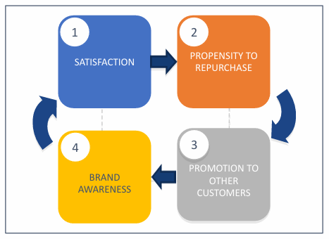
BRS (Brand Recommendation Score) Index

Supporters: customers with a score between 8 and 10. Very loyal to brand and could become brand ambassadors
Neutral: score between 6 and 7. On average satisfied, but could switch to competitor if driven by appropriate marketing actions, not particularly loyal
Opponents: score between 0 and 5. Dissatisfied customers who could complain about negative experiences via reviews.

Brand Recommendation Score calculated by subtracting percentage of detractors from promoters. BRS can be between -100 (all customers detractors) and +100 (all customers promoters).
BRS = % supporters - % opponents

Customer satisfaction: methodological approach
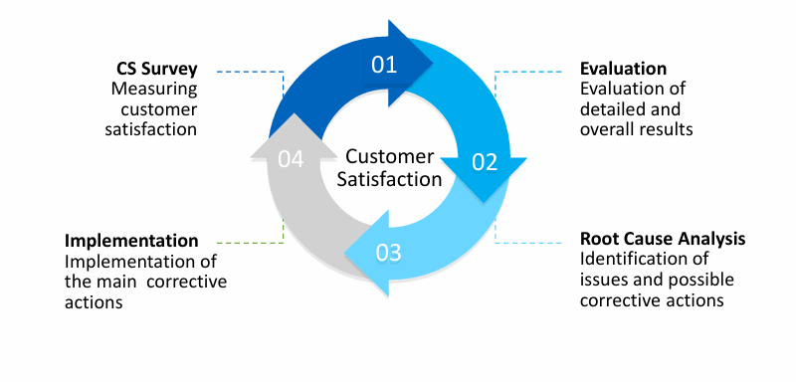
Customers satisfaction - traditional approach

Customers and employees’ satisfaction - innovative approach
Goal: compute unique weighted satisfaction score that reflects customers and employees’ perception from multiple point of view.
Value delivered:
- identification of routes to customer and employees’ loyalty with data driven approach
- bottom up understanding of dissatisfaction triggers
- monthly updates of score to understand variation over time of all satisfaction drivers
- insights on relation between satisfaction index and revenues’ increase

